Here,

Start Node : Shawon’s house

Goal Node : UAP

Cost in Distance : kilometer (km)

**State space:**

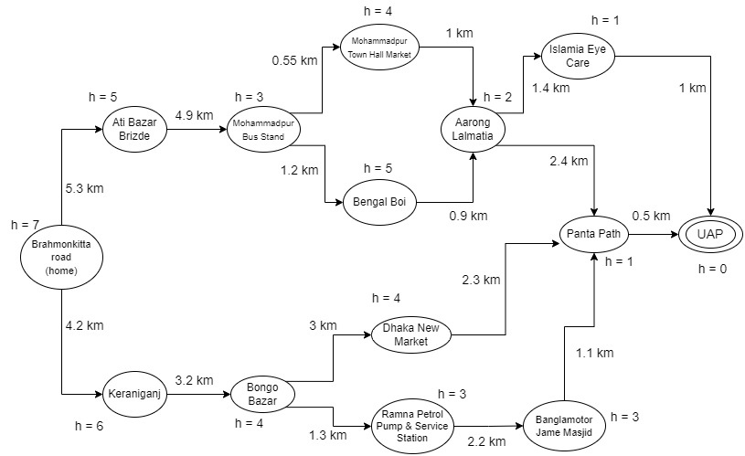

**Heuristic Values:**

h(Brahmonkitta road) = (43 % 4) + 4 = 3 + 4 = 7

h(Ati Bazar Brizde) = (43 % 5) + 3 = 3 + 3 = 6

h(Mohammadpur Bus Stand) = (43 % 5) = 3

h(Mohammadpur Town Hall Market) = (43 % 5) + 1 = 3 + 1 = 4

h(Bengal Boi) = (43 % 5) + 2 = 3 + 2 = 5

h(Aarong Lalmatia) = (43 % 2) + 1 = 1 + 1 = 2

h(Islamia Eye Care) = 43 % 2 = 1

h(Panta Path) = 43 % 3 = 1

h(Keraniganj) = (43 % 4) + 3 = 3 + 3 = 6

h(Bongo Bazar) = (43 % 4) + 1 = 3 + 1 = 4

h(Dhaka New Market) = (43 % 4) + 1 = 3 + 1 = 4

h(Ramna Petrol Pump & Service Station) = (43 % 4) = 3

h(Banglamotor Jame Masjid) = (43 % 2) + 2 = 1 + 2 = 3

h(UAP) = 0

**Path cost :** 4.2 + 3.2 + 1.3 + 2.2 + 1.1 + 0.5 = 12.5 km

**Shortest path:**

Brahmonkitta road (home) -> Keraniganj -> Bongo Bazar -> Ramna Petrol Pump & Service Station -> Banglamotor Jame Masjid -> Panta Path -> UAP